System Modeling:
- Rob updates the use case diagram to reflect the addition of the database format documentation in the architectural design:
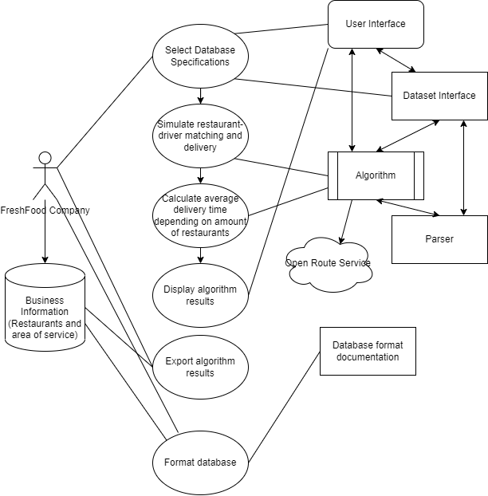
- Danny created a business diagram to show how other businesses could use Freshtime with their own curated datasets.

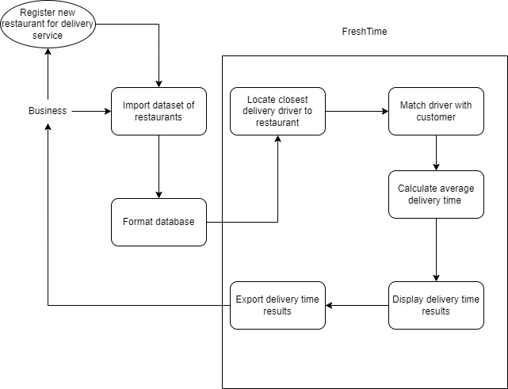

Design Specification:
- Rob created a User Interface Specification document to show how the user interface implementation fulfills the use cases and how to navigate the system.

Design Implementation:
- Rob designed the user interfaces for the FreshTime application using JavaFX to fulfill the use cases for the user interaction with the system.
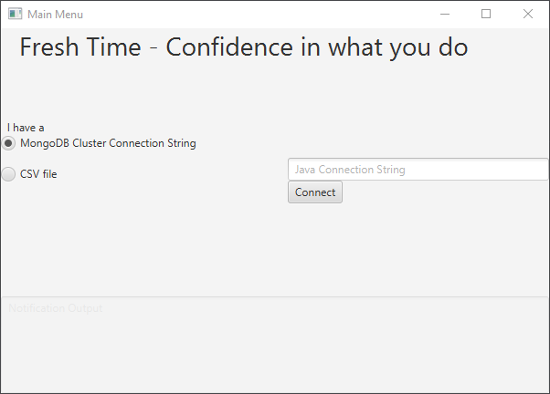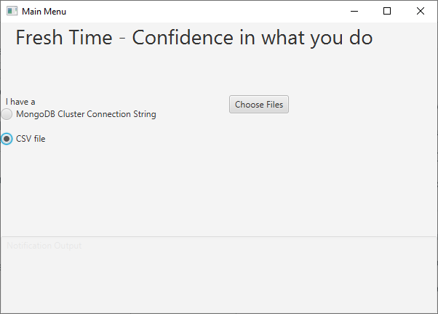
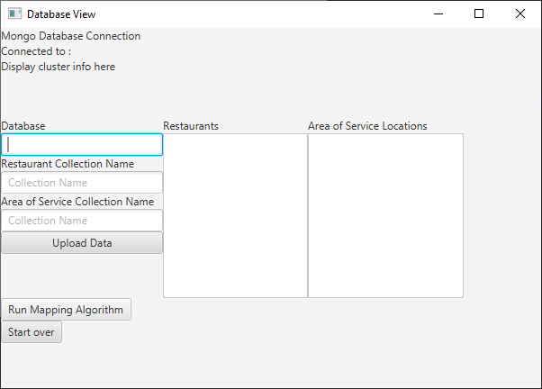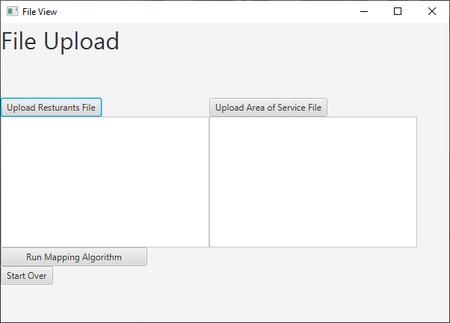
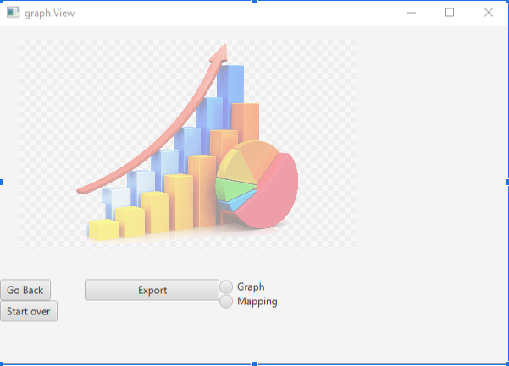

- Rob programmed the back end navigation between the user interface and user selection and upload of supported databases. Supported databases currently include local file upload formatted to the database format specifications and mongoDB to the same specifications.
- Rob implemented the MongoDB ping command code in java found here:
  - https://stackoverflow.com/questions/17194268/mongodb-check-connection-to-db
Dependable attribute:
- Rob researched MongoDB documentation for utilizing the ping command and just the cluster java connection string. This is useful because it allows the system to test whether or not the user has entered a valid database before proceeding. This adds to the resilience and reliability of the program because it has confirmed this connection to the application.
- Kiernan further researched OSM/ORS backend API implementation to attempt to host locally on computer, deployed using Docker. (*ORSBackend_Initialization_04/16/2022)
  - Set up MongoDB Database as backup (limited at 500 queries/hour) with accompanying documentation.
    - Documentation is not fully completed, but will be during Sprint 5.

Project Management Concept:
- Kiernan created a Gantt Activity Diagram for Sprints 1 to 4, will update with Sprint 5 later this week.
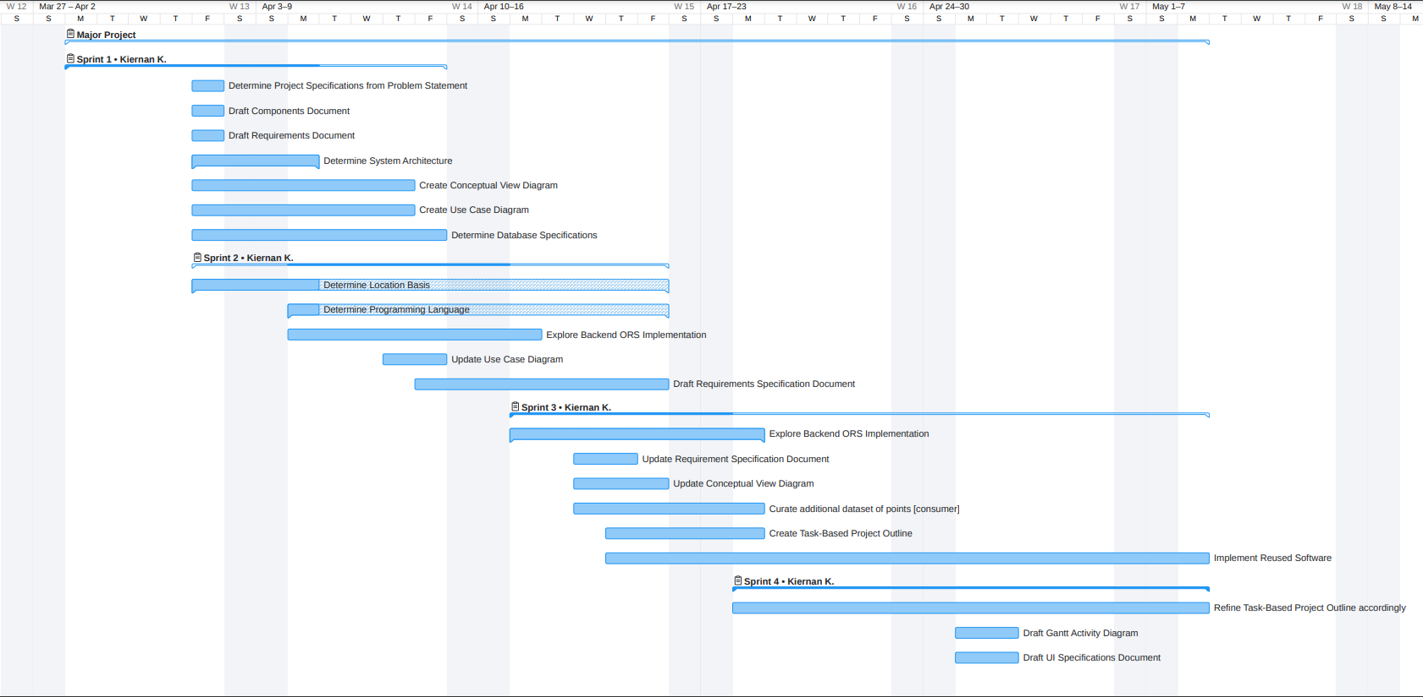
- Kiernan and Rob updated the FreshTime Plan Document with additional tasks and pre-existing ones.
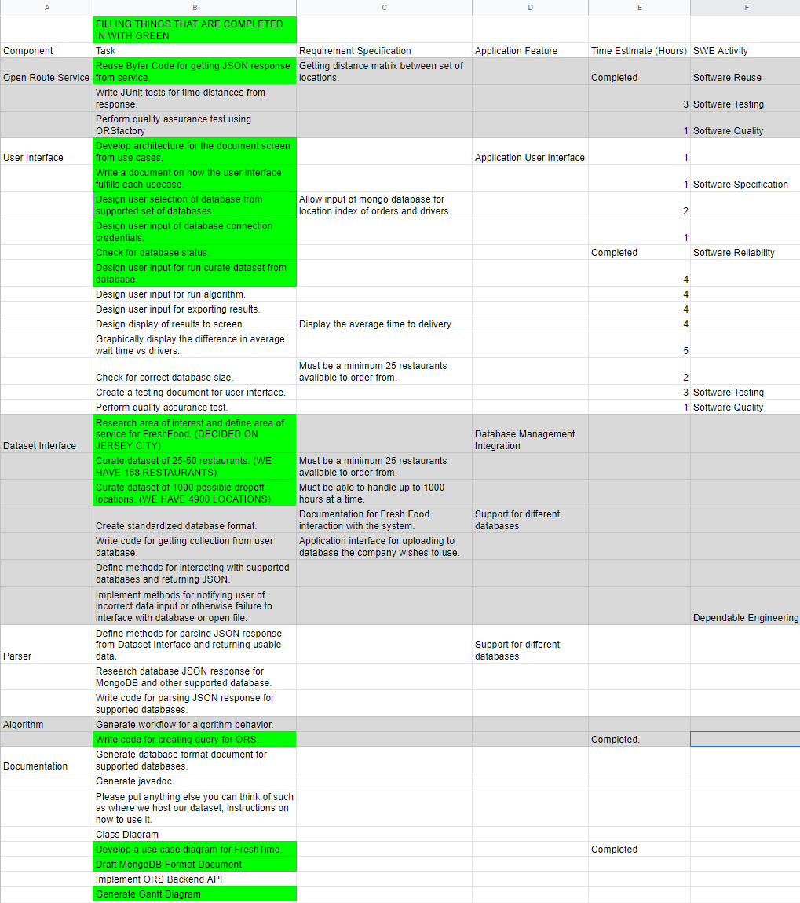

Advanced SWE Topic
Safety
- Rob created a Safety Diagram for connecting to a mongoDB database. This diagram proves that there is not a possibility for a user to connect to a database with incorrect credentials or for the system to proceed even though a connection is not successfully established.
